**Problem Statement 6.2.1**

=================================================================

• Fetch date and temperature from temperature_data where zip code is greater than

300000 and less than 399999.

Output:

**Hive Input Command:**

SELECT data_mmddyyyy, temperature FROM temperature_data WHERE zipcode > 300000 AND zipcode < 399999

;

**Output 6.2.1:**

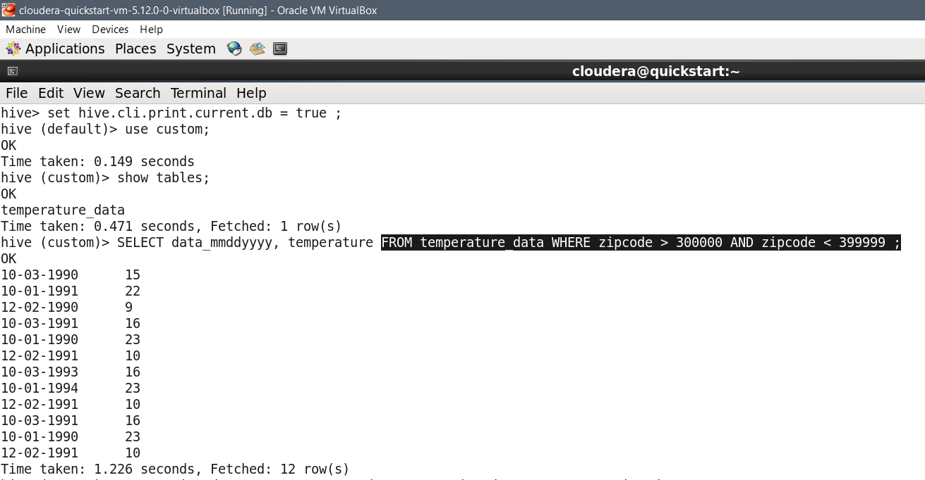

=================================================================

**Problem Statement 6.2.2**

=================================================================

• Calculate maximum temperature corresponding to every year from temperature_data

table.

**HIVE INPUT COMMAND:**

SELECT substr(data_mmddyyyy,7,4) AS year , max(temperature) AS max_temperature FROM temperature_data GROUP BY substr(data_mmddyyyy,7,4)

;

**Output 6.2.2:**

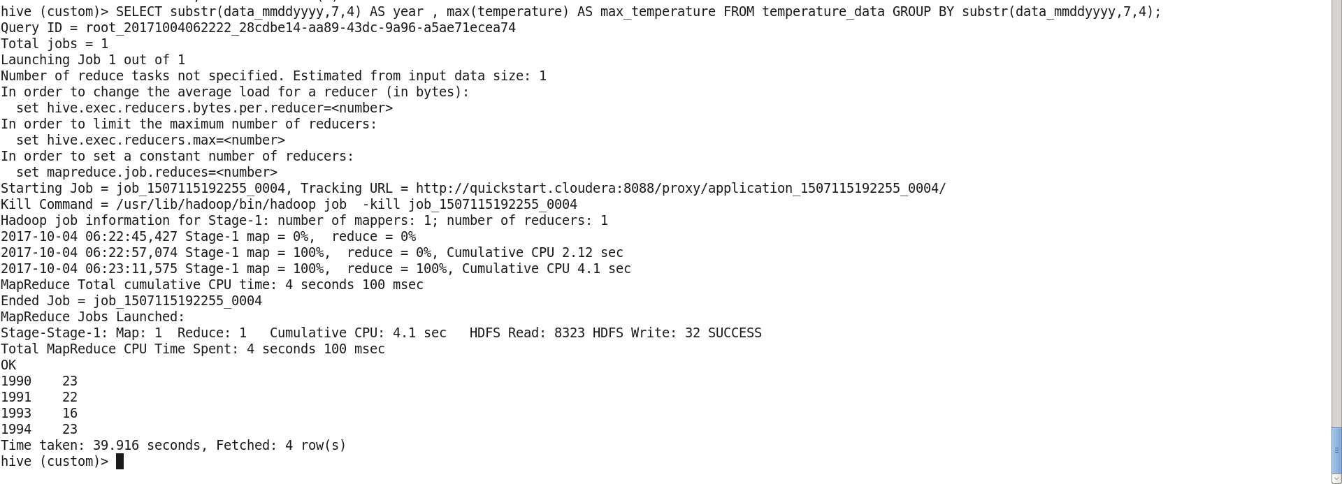

=================================================================

**Problem Statement 6.2.3**

=================================================================

• Calculate maximum temperature from temperature_data table corresponding to those

years which have at least 2 entries in the table.

**HIVE INPUT COMMAND:**

SELECT SUBSTR(data_mmddyyyy,7,4) AS year , MAX(temperature) AS max_temperature

FROM temperature_data GROUP BY substr(data_mmddyyyy,7,4)

HAVING COUNT(SUBSTR(data_mmddyyyy,7,4)) > 1 ;

**OUTPUT 6.2.3:**

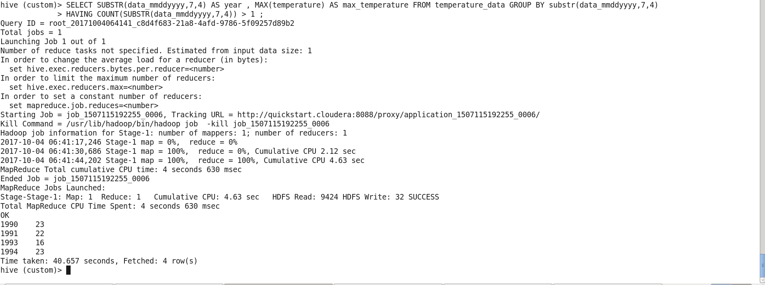

=================================================================

**Problem Statement 6.2.4**

=================================================================

• Create a view on the top of last

query, name it temperature_data_vw.

**HIVE INPUT COMMAND :**

CREATE VIEW IF NOT EXISTS temperature_data_vw AS

SELECT SUBSTR(data_mmddyyyy,7,4) AS year , MAX(temperature) AS max_temperature

FROM temperature_data GROUP BY substr(data_mmddyyyy,7,4)

HAVING COUNT(SUBSTR(data_mmddyyyy,7,4)) > 1

;

SELECT * FROM temperature_data_vw

;

**OUTPUT 6.2.4 ;**

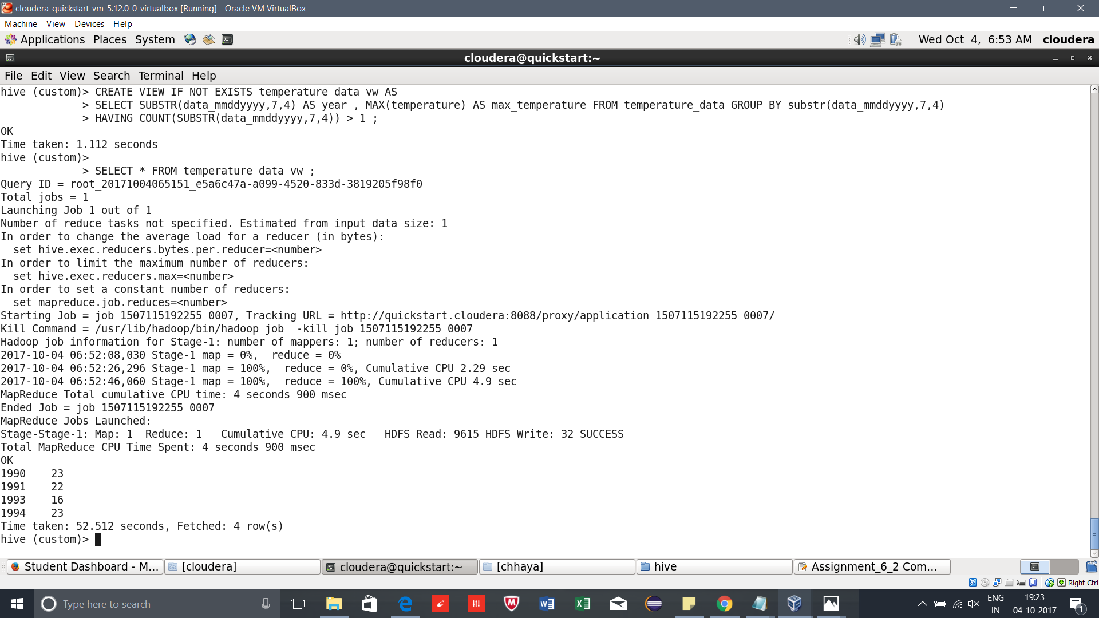

=================================================================

**Problem Statement 6.2.5**

=================================================================

• Export contents from temperature_data_vw to a file in local file system, such that each

file is '|' delimited.

**HIVE INPUT COMMAND:**

INSERT OVERWRITE LOCAL DIRECTORY "/home/cloudera/chhaya/hive_view/export_view.txt"

ROW FORMAT DELIMITED FIELDS TERMINATED BY '|'

SELECT * FROM temperature_data_vw

;

**OUTPUT 6.2.5 :**



